Types of Attributes
# Source: AI Source: Provided by: [Data Path: Persons Table -> ID Column: 1, Name_En Column: Motasem Essam] -> From: [Chatgpt (GPT‑5 Mini)] on [8/7/2025]
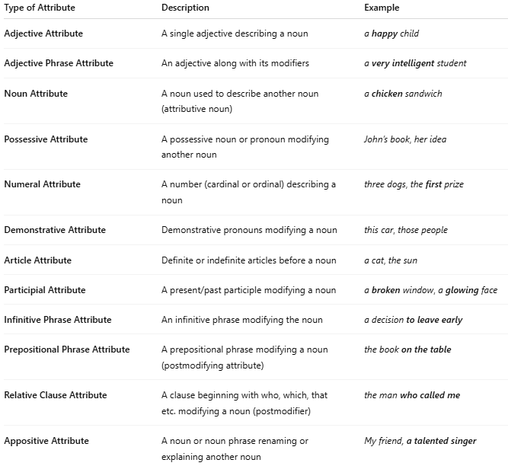

Type of Attribute | Description | Example
Adjective Attribute | A single adjective describing a noun | a happy child
Adjective Phrase Attribute | An adjective along with its modifiers | a very intelligent student
Noun Attribute | A noun used to describe another noun (attributive noun) | a chicken sandwich
Possessive Attribute | A possessive noun or pronoun modifying another noun | John’s book, her idea
Numeral Attribute | A number (cardinal or ordinal) describing a noun | three dogs, the first prize
Demonstrative Attribute | Demonstrative pronouns modifying a noun | this car, those people
Article Attribute | Definite or indefinite articles before a noun | a cat, the sun
Participial Attribute | A present/past participle modifying a noun | a broken window, a glowing face
Infinitive Phrase Attribute | An infinitive phrase modifying the noun | a decision to leave early
Prepositional Phrase Attribute | A prepositional phrase modifying a noun (postmodifying attribute) | the book on the table
Relative Clause Attribute | A clause beginning with who, which, that etc. modifying a noun (postmodifier) | the man who called me
Appositive Attribute | A noun or noun phrase renaming or explaining another noun | My friend, a talented singer

